The Digital Doctor

|  |  |
| --- | --- |
| **Team Name** | **TeChNoZ** |

|  |  |
| --- | --- |
| **Project Title** | **Dengue Control System** |

|  |  |
| --- | --- |
| **University** | **Government College University** |

|  |  |
| --- | --- |
| **City** | **Lahore** |

|  |  |
| --- | --- |
| **Project Completed (in percentage)** | 70 |

# Team Members Details:

|  |  |  |  |
| --- | --- | --- | --- |
| **S#** | **Name** | **Mobile Number** | **Email Address** |
| **1.** | Waqas Ahmed | 03317218364 | [Waqas716@gmail.com](mailto:Waqas716@gmail.com) |
| **2.** | AWAIS MANZOOR BAJWA | 03324863935 | [Awais.bscs.09@gmail.com](mailto:Awais.bscs.09@gmail.com) |

Hardware Used

**Server:**

Windows XP or higher

Any hardware server machine according to number of Patients

**Patient side:**

Android Phone, Website

Devices for performing tests like Digital Glucometer, digital weight machine, etc.

**Doctor side:**

Android phone, Website

Window XP or higher

**Software Used:**

* Visual Studio 2010
* Android Development Kit
* Eclipse

**Implementation**

# INTRODUCTION:

## PURPOSE:

This document contains the introduction to our Idea (Technology) in detail. It includes the project’s scope, and its intended audience, an overview of current technology or systems available in the market, along with the proposed system’s overall description; the proposed product perspective, product features etc. The detailed advantages of our proposed system in today’s world and lastly the document include the approach to develop the software and its output.

## PROJECT SCOPE:

The project deals with the domain of medicine and health of a person as to how it can be maintained using technology. According to our idea, the project developed would be a combination of software & hardware that will be used for monthly, weekly or even daily checkups of a person who is suffering from dengue without visiting a doctor or clinic and the report of those checkups will be automatically transferred to associated doctor of the patient.

The product will provide the user with a variety of devices, e.g. which can check fever, person’s glucose level, sugar level, blood pressure, pulse-rate height and weight measurements etc. and not just that it’ll put reminder’s for the patient for check-ups, the software will automatically save the result of every check-up performed and transfer it to the associated doctor which can also then prescribe the patient. Additionally, this will form a medical record of a person and the person’s medical history will be maintained and will be updated as the person performs regular checkups.

## INTENDED AUDIENCE:

The document is intended for all the analysts, designers, and developers of the fields related to the product; which involves the field of Medicine, Health equipment manufacturers, the software designers, software developers, practitioners and the analysts and testers of these fields; with specifically intended for the ACM people conducting the Dev Fest.

As the product is basically for the people to make their lives healthier by keeping regular check-ups of their fitness in order to be safe from various diseases, the product has its major in the everyday life of a person. The users of the system are the people (patients) and the concerned doctor for those patients.

# CURRENT SYSTEMS IN MARKET:

Current Technology in the market gives us certain devices like to check blood-pressure, sugar or glucose level, digital thermometer etc. All such devices available, do not come in one package or in one form together, also there are not many features that these devices offer except for what these measure or made for, and also no record of the result is saved. Some of the devices commonly used by the people are as shown.

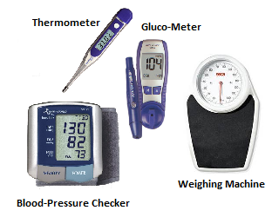

## PRODUCT PRESPECTIVE:

The product formed is a new product not already existing in the market. The product has derived certain technology from the market like some digital instruments that are used personally by the patients at home. Our purposed system will deal with two types of categories of users i.e. doctors and product owners. A device will be placed in home and it will be connected to a server that will be placed in a nearby hospital.

The software will put reminders of the checkups, graphs indicating the blood glucose level n plasma glucose level at different times of day, the overall carbohydrate consumption, the total insulin delivered plus variation between blood pressure, and exercise manual and the overall statistical evaluation of each checkup result or measurement.

* **PRODUCT FEATURES:**

The product would provide the user with following features and functionalities:

* Height and weight measurements
* Blood pressure measurements
* Examination of hands, fingers, feet, and toes for circulatory abnormalities
* Blood tests for fasting blood sugar, hemoglobin and cholesterol
* Family history of diabetes, cardiovascular disease, and stroke
* Prior infections and medical conditions
* Including above features this application will be specialized for dengue patients.

The software will also educate the user by providing a awareness messages of diseases, the statistical evaluation of each check-up and also will inform the user if certain results are not safe, will alarm the user and the his/her doctor both, and accordingly the associated doctor can send the patient any sudden required prescription. The Graphs included will show the user the pulse rate, glucose levels, cholesterol levels etc. There software would be Easy-to-Use not at all complicated. The User can also check the Past History of all his reports and can stay informed of all his medical record.

* **COMPLETE PRODUCT FUNCTIONALITIES:**

|  |  |  |
| --- | --- | --- |
| **FUNCTIONALITIES** | **PURPOSE** | **FREQUNCY OF USE** |
| Separate Login  Account For Each User | For Privacy And Security | High |
| Alarm System | As Reminder for Patient and doctor | High |
| Check-Up | Conducts Test and send the data to respected doctor (digital device required for test should be connected) | Depends |
| Check Temperature | To Check if Normal (Depends Upon Patient Type) | Moderate |
| Check Blood Pressure | To Check if Normal  (Depends Upon Patient Type) | Moderate /  Daily(Depends Upon Patient Type) |
| Check Blood-Sugar Level | To Check its Percentage  (Depends Upon Patient Type) | Moderate /  Daily(Depends Upon Patient Type) |
| Check Cholesterol Level | Check if Normal /  Percentage etc | Moderate |
| Check Hemoglobin | To Check Percentage | Moderate |
| Measure Weight/Height | To Check Weight/Height | High |
| View Past History | To See Medical Record | Moderate |
| Measurements with  side by side Statistical  Evaluation & Graphs | For User’s Better  Understanding of the  Test Results. | High |
| Inform about alarming  conditions to Patient and send emergency message  to the associated doctor | Doctor is informed of the  Patient’s Condition & Sends instant Response | Low |
| View Doctors Prescriptions | To Check Doctors  Response for the Result  Of Check-Up | Moderate |
| View Doctors Message | To Check Doctors  Response for the Result  Of Check-Up | Moderate |
| Doctor View’s test’s Reports | Doctor Check The  Received tests Report | Moderate |
| Doctor Sends A Message  to Patient | Doctors Response  to Patient | Moderate |
| Doctor’s look for  Patient’s Medical Record | Doctor Checks Patient’s  Medical History | Moderate |
| Awareness Messages for  Addiction / Severe Viral  Infections etc. | To keep the family  Or the User aware. | Moderate |

**Working Environment:**

Our purposed system will deal with two types of categories of users i.e. doctors and patient’s.

**User End:**

A mobile application will be created for android, and iPhone. That will alarm daily at its manually set alarm time. Dengue Patient can then check their body performance everyday regularly. Home owner will first find a login or to create account option on the GUI. After logging in the system, appear the **Four Main Menu Functions for the User: “Tests”, “Prescription”, “Contact Doctor” and “Patient History”.**

**Doctor’s End:**

The patient’s phone application will be connected with a server in nearby hospital and the doctor will be able to check each change in his patient’s health. The system in hospital will be a client server architecture i.e. each doctor will be provided a client computer where he will be able to see his patient’s details.

Doctor will initially see a login window where he will enter his username and password. This is done to keep the system secure from external or unauthorized use. After the Doctor logs in, the Main Menu will appear on the screen. **The Main Menu for Doctor has the options of “Patient Profile”, “Contact Patient”, “Patient History”, “Disease History” and “notifications”.**

**Server End:**

At server end there will be a database of doctors and patients. And a web service to which android application and doctors application will connect.

# Hospital Flow Diagram

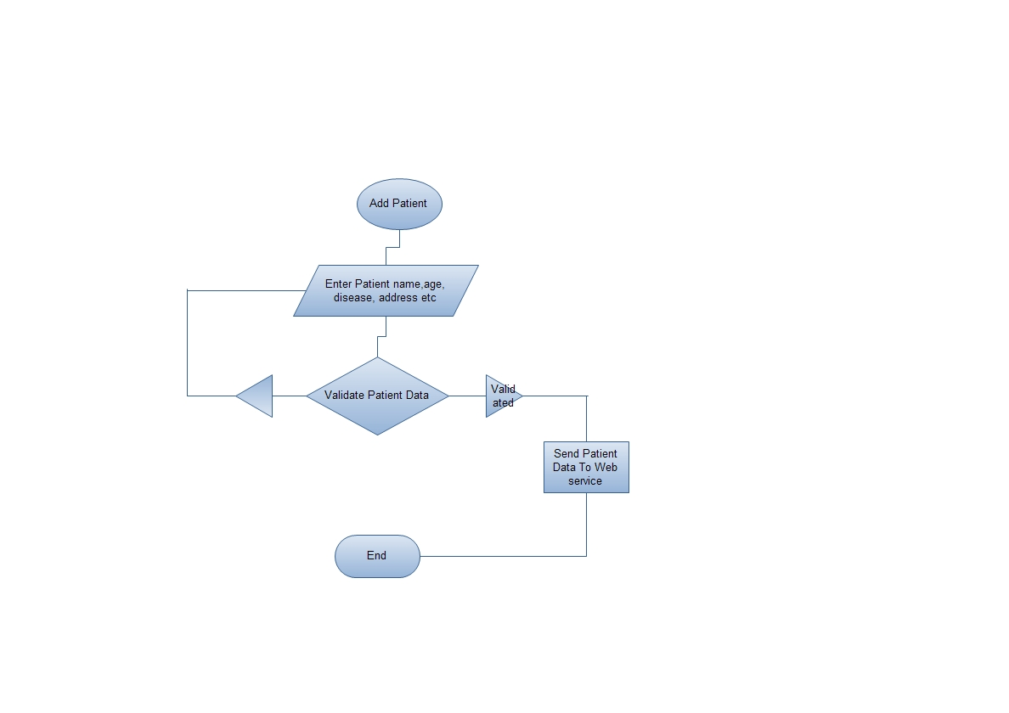

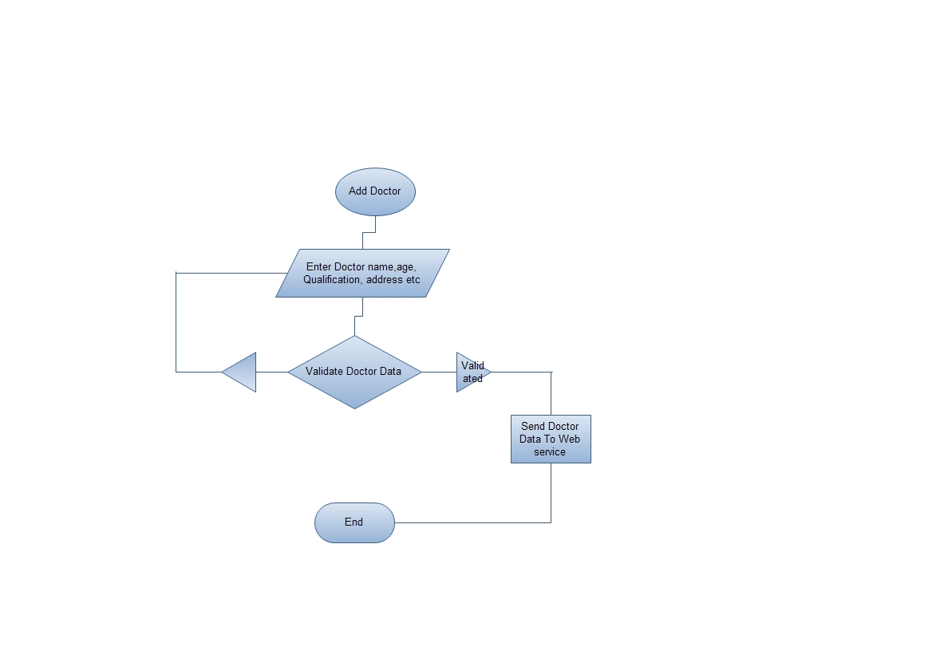

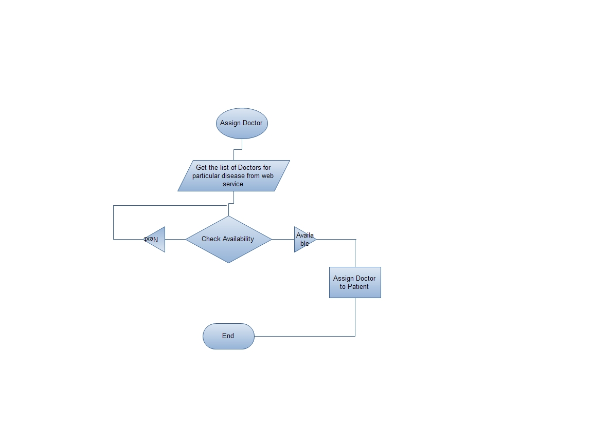

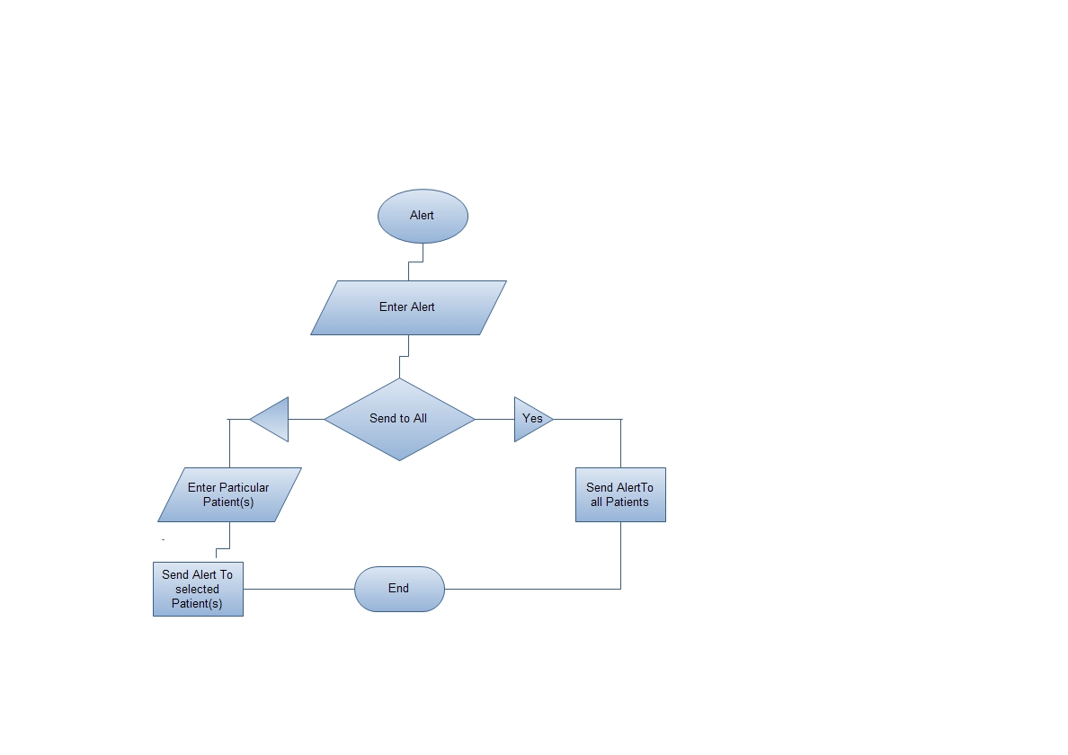

# Doctor Flow Diagram

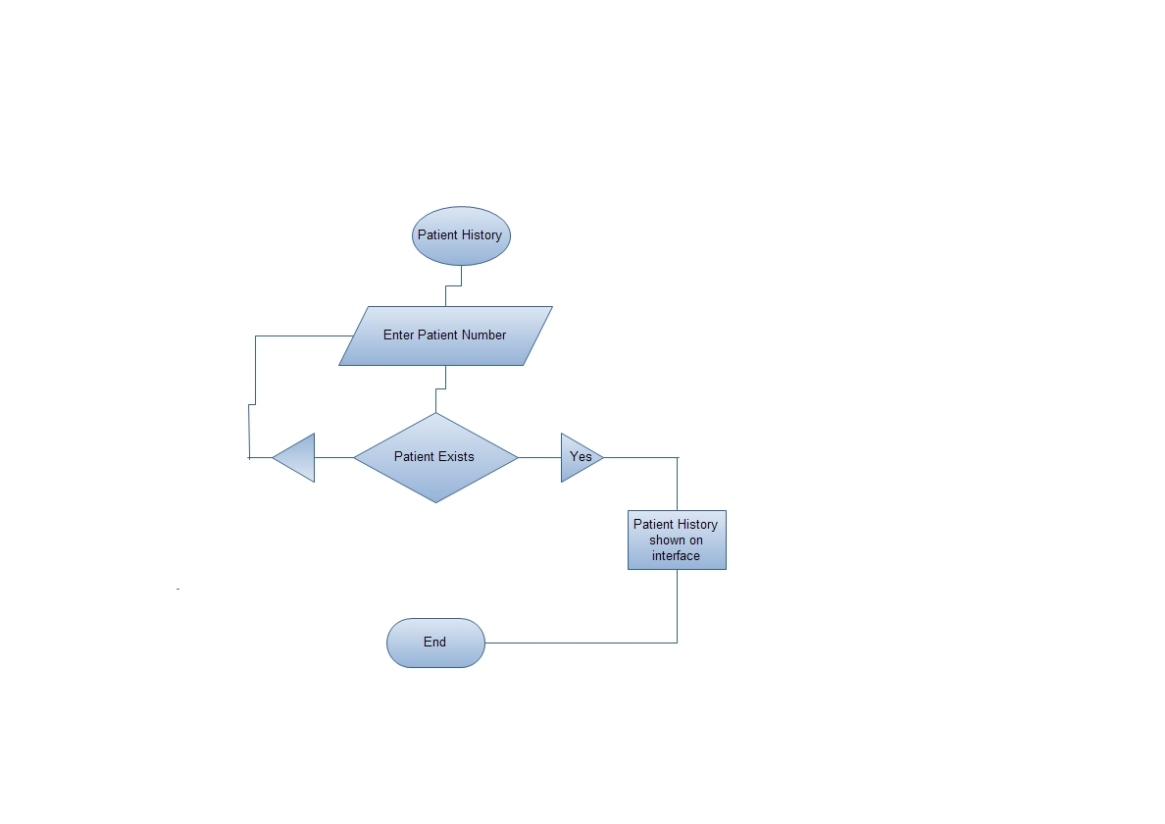

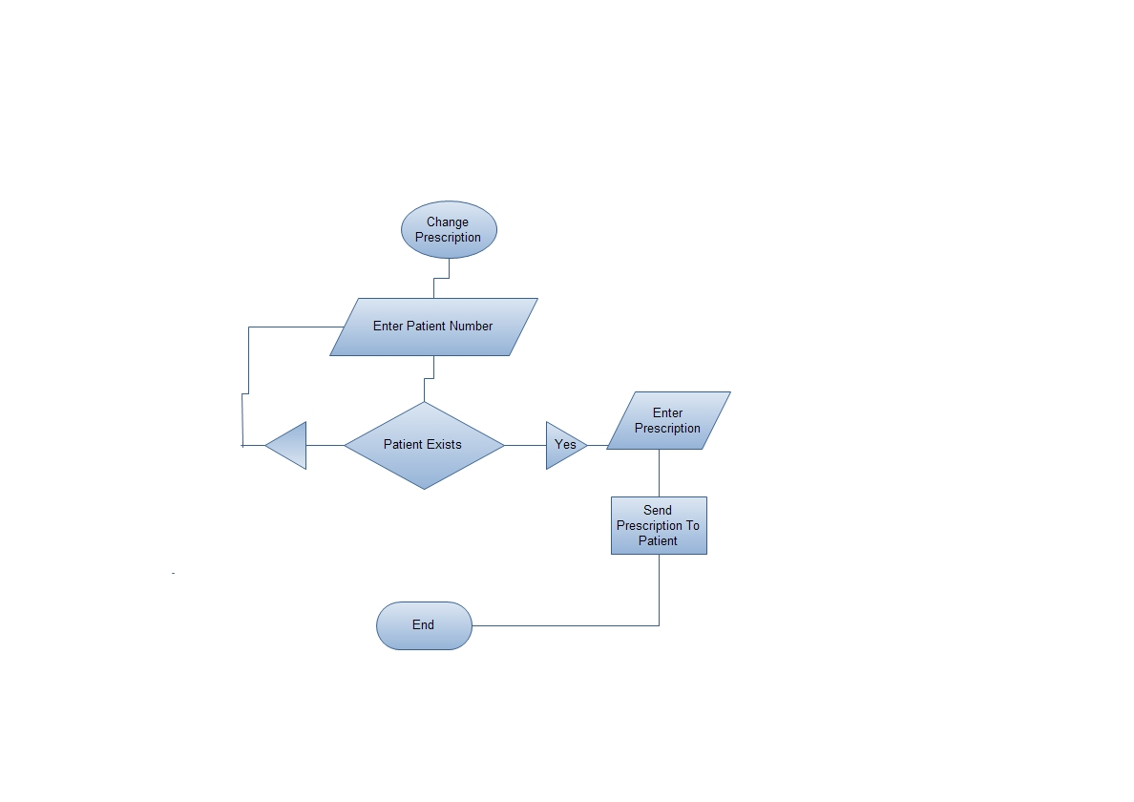

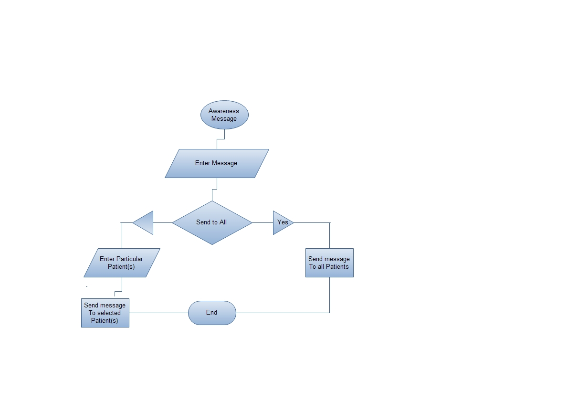

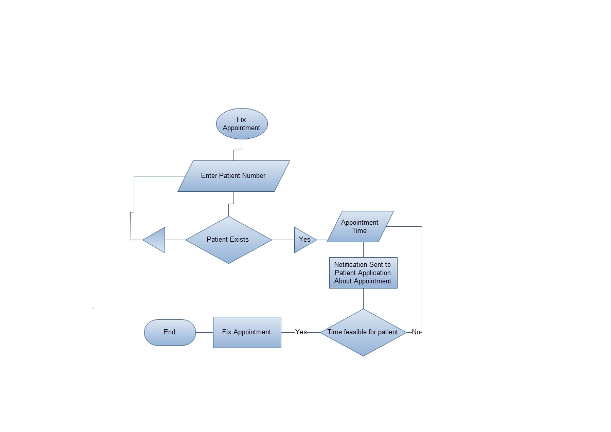

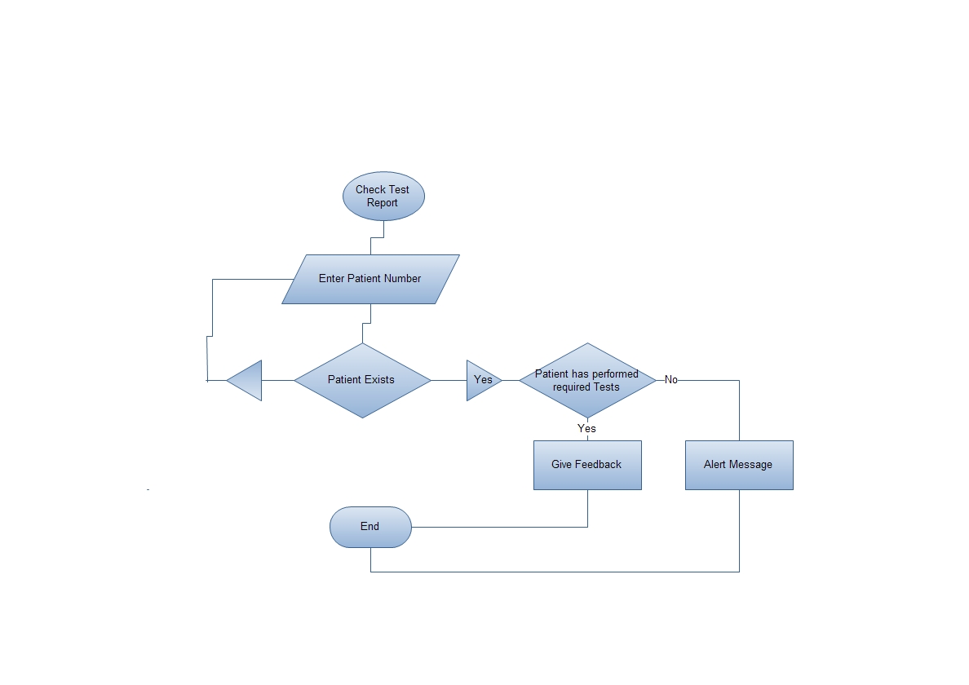

# Patient Flow Diagram

